
Quick Guide in setting up a database in MyData

Introduction
MyData is a very quick database tool, set up to quickly set up the data a game could need. It's not nearly as advanced as tools like MySQL and it lacks features like quick searching or foreign keys and all that blah blah blah. All that stuff was not what I had in mind when I created this tool. All I needed was a quick tool in which I could quickly work out the data a game could need. Especially when creating RPG games a lot of data could come by and then a tool to quickly organize it, and output the results to Lua. Since I was back then still looking in the question if PyGame could be a good tool for me or not (sadly I decided it to be crap due to its poor distribution possibilities) I also built in a Python exporter.

The girl serving as a mascot was NOT drawn by me and I don't know who did. I found her in a public domain library, and decided to put her in place to have 'something nice to see' while working. If she's not public domain, show me evidence and I'll replace her.

Installation
It's very very important to keep in mind when installing MyData, that it was just a very quickly whipped up tool and that I didn't care about official Unix file management rules at the time. Also since on my own system MyData was only to be installed on a portable harddisk it was for me only the quicker way to go.

That being said it is particularly for Linux and Mac users very important to do things differently than you are used to do. For Windows it may also be a safer road to go.

I strongly recommend NOT to install MyData on a flash device, such as USB stick or SD cards. MyData tends to need to rewrite some files quite a lot and that tendency can destroy an USB stick rather quickly, same goes for CD-RW disks. Floppy disks, diskettes, hard drives, portable hard drives should be no problem.

The best way to go is to make MyData live in its very own folder. All it needs is the application file/bundle (MyData.exe in Windows, MyData.app on Mac and MyData in Linux) and in the very same folder a sub-folder named 'Databases'. Users of Unix based systems such as Mac and Linux should make sure that the Databases folder has full read and write access. I used a portable harddrive (ExFAT formatted) for this myself, but you can also use your home/users folder for this, as long as MyData has full read and write access to the Databases folder.

Setting up a database
MyData cannot set up a database structure by itself, you will need a text editor for that. On Windows Notepad can do, although I do recommend to use Notepad++ or Geany. For Mac users I must strongly impress NOT to use TextEdit for this, as TextEdit will by default only generate rich text files, and those files are completely beyond MyData's understanding. I use Geany for this on my own Mac, but basically any programmer's editor can do, same goes for Linux. True Unix junkies may consider Emacs or VIM or Nano.

A database file is just a text file, please note that MyData will modify a part of this file. I will tell more further on.

A database file in MyData has several 'segments'. All of them must be headed with a command prefixed with a [ and suffixed with a ].
The segments are [system], in which you can set some configuration settings.
The [page] segment can be used to divide your screen in pages. This is pretty important as MyData cannot check if stuff still fits on your screen, so you need to make a new page when that happens, and it gives more overview to yourself. It does not matter on which page the data lives, as for the exports the data is the same.
The [default] segment is used to fill in specific default data to the database fields.
The [records] segment is where the data itself lives, and this segment should always come last, and is modified by MyData. Best is not to touch this segment at all and when non-existent MyData will create it itself. Meddling with [records] or not leaving it last can lead to 'damage'.

All lines prefixed with a # will be ignored. This system has been brought in place to make commenting possible.

[system] segment
Basically just some fields you need to define. The syntax is just:
<config-field>=<data>
Leading spaces will be trimmed so you can just add them to make it more beautiful ;)
The config field names are case INSENSITIVE, so you can use upper and lower case in those any way you place.
Field | Function | Notes
OUTPUTLUAREC | Defines directory to output records in .lua format | Each record will be stored in its own .lua file  You can load these files as modules with 'require'.
OUTPUTLUABASE | Defines file to output entire database in .lua format | The entire database will be put in one .lua file. You need to fill this one out with the full path name.  You can load these files as modules with 'require'.
OUTPUTPYTHONREC | Defines directory to output records in .py format | Each record will be stored in its own .py file. You can read these with the 'import' command.
OUTPUTPYTHONBASE | Defines file to output entire database in .py format | The entire database will be put in one .py file. You need to fill this one out with the full path name. You can read these with the 'import' command.
OUTPUTMYSQLBASE | Defines file to export in MySQL format. | This has never been fully tested.
LICENSE | Add license text | This will be added as a comment in the exported files.
AUTOOUTPUT | When set to 'YES' it will export to all set systems whenever you save the database.
REMOVENONEXISTENTFIELDS | When set to 'YES' any fields without a value will not be exported.

Please note that the system has never been designed to be used on multiple platforms, so you may need to change these settings when you are using a different platform.
Windows users should be aware of the fact that any drive that is not C: may have different drive letters whenever you restart Windows or whenever a certain device is unmounted and remounted. This is a Windows issue, so nothing I can do something about, but it can cause MyData to crash. If the exported files need to be on the same device as on which MyData is installed you can 'cheat' around this by not mentioning the drive letter. So in stead of writing “F:\Myoutput\output.lua”, write “\Myoutout\output.lua”. Of course this trick would only work if MyData is on the same drive in this example case that would be F:
When all data lives on your C: drive, then don't bother.

[page] segment
Now the page segment allows you to create a page and to define stuff in it. The syntax of the page header is [page:<pagename>]. The names of these pages do not affect the data at all, but they are in the header on screen.
Please note the number of fields on your page. There is no official limit, but MyData is not able to see if there are more fields than your screen can handle, so make sure you create a new page whenever you see this happening.

Now basically you can define all fields like this.
<datatype> <fieldname>
The names of the datatypes are case insensitive, the fieldnames are not, due to their export functionality to Lua and Python which are both case sensitive languages, and overall it was the better way to go, I'm afraid.
Type | Function | Notes
strike | Line on screen | Doesn't need a name, just draws a line on the workscreen as a separator
info | Info on screen | In stead of a name this just puts extra info on the screen. Handy as a reminder or when multiple people need to use your database.
string | String value | Please note, only ASCII values are taken well. É or å or any letters like that will cause MyData to malfunction.
int | Nummeric value | Alternatively you can also use 'double' for this.
color | Color value | A table containing the fields R,G,B. The values for these fields may be any number from 0 till 255.
bool | True or false
mc | Multiple Choice | The answers can be added to this field with the lines prefixed with a '@'. The first line not prefixed with '@' will no longer be part of this 'mc' clause. I will limit myself to the simplest '@' commands to keep it simple, perhaps a documents with tricks for advanced users may explain them all.
@i | Item for mc | May just contain a string value
@f | All contents of a folder as items. | - Please note this works recursively  - / is used as folder separator, even on Windows.  - This feature is also compatible with the .JCR package system, so giving the name of a .JCR file will include all files it contains as items.
@db | Include another database | This will include all the records of an other database. Just type the name of that database and this will happen.

Set everything up? Then it's time to make MyData do its magic!
When you set everything up, you can get MyData on the run at last. Run the application and you'll first get a list of databases in the Databases folder. Pick the one you want and you can get to work.
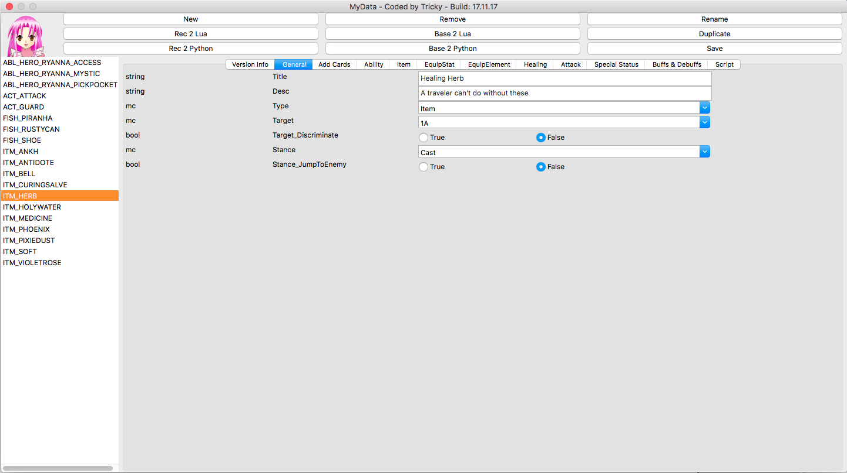
Above you see a screenshot of the database I used to create the inventory items and special abilities and other combat abilities for 'Sixty-Three Fires of Lung'. This shot was taken in Mac OS Sierra, the layout may differ a little in different Mac versions, and look entirely different on Linux and Windows, but where to find all stuff and what it all does will all be the same. ;)
The 'base 2' buttons are basically deprecated and will likely be replaced by a better export system in the future. The other buttons are pretty self-explaining:
- New creates a new record. Record names can only contain (uppercase) letters, numbers and underscores
- Remove destroys a record (will ask to confirm).
- Rename Renames the record
- Duplicate copies all data of a record into a new record. It's a bit of a 'cloning' feature. This is handy when you need new records that are 90% alike an existing record with only a few tiny changes.
- Save saves the database and exports to Lua or Python if AUTOEXPORT is set to 'YES' in the system segement. Please note this happens automatically when exiting MyData as well (without asking), the button is only there, so you can save on a regular bases, as MyData has no recovery system for system crashes.

